**GitHub Copilot – Getting started (Visual Studio Code)**

**Prerequisites:**

* Latest version of Visual Studio Code. See the [Visual Studio Code download page](https://code.visualstudio.com/Download).
* Create a GitHub account with your Syntegon email address.
* Download the GitHub Copilot extension. Click the extension button on the left sidebar and search after “GitHub Copilot”. Install the highlighted version.

Ein Bild, das Text, Screenshot, Software, Computersymbol enthält.

* Click the *Accounts* button on the sidebar and select *“Sign in with GitHub to use GitHub Copilot”.* Follow the instructions and sign in to your GitHub account.

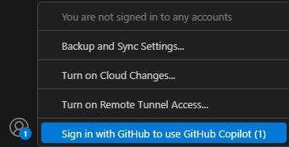

**Chat with GitHub Copilot:**

1. Open an existing code file.
2. 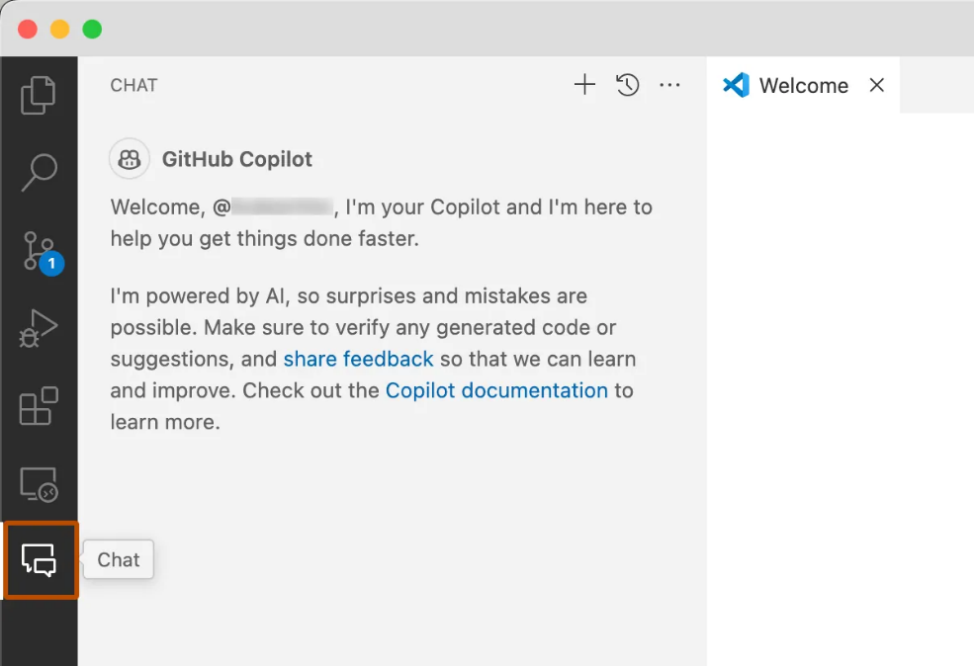Open the Chat view from the Activity Bar.
3. At the bottom of the chat view, in the chat input field, type*: explain this file*.
4. Press *enter*.
5. In the editor, select one or more lines of code that are not commented.
6. In the chat input field, type: *add comments to these lines*.
7. If you like the comments that Copilot suggests, hover over the suggested code in the chat view and click the "*Insert at Cursor*" icon to replace the selected lines with the suggested code.

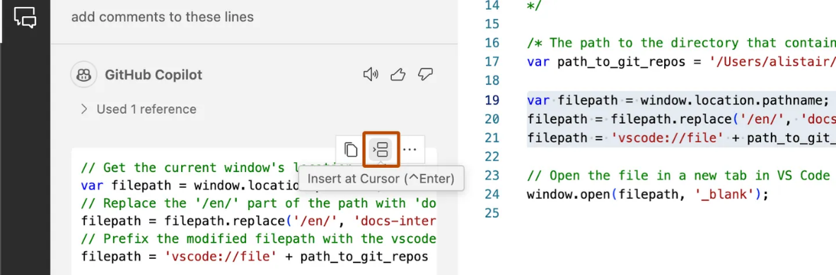

**Additional ways to access Copilot Chat:**

* Inline: To start an inline chat directly in the editor or integrated terminal, enter *Ctrl+i.*

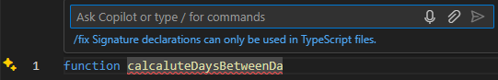

* Quick chat: To open the quick chat dropdown, enter *Shift+Ctrl+i.*

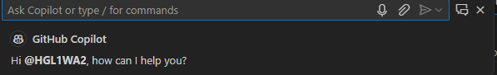

* Smart actions: To submit prompts via the context menu, right click in your *editor*, select Copilot in the menu that appears, then select one of the actions. Smart actions can also be accessed via the sparkle icon that sometimes appears when you select a line of code.

Ein Bild, das Text, Screenshot, Software, Multimedia-Software enthält.

**Code completion:**

1. Open Visual Studio Code
2. Create a new JavaScript(*.js) file.
3. In the JavaScript file, type the following function header:

*function calculateDaysBetweenDates(begin, end) {*

Ein Bild, das Text, Screenshot, Schrift enthält.

1. To accept the suggestion, press *Tab*.

**Useful links:**

* [**Quickstart for GitHub Copilot: https://docs.github.com/en/copilot/quickstart?tool=vscode#prerequisites**](https://docs.github.com/en/copilot/quickstart?tool=vscode#prerequisites)
* [**Getting code suggestions in your IDE with GitHub Copilot: https://docs.github.com/en/copilot/using-github-copilot/getting-code-suggestions-in-your-ide-with-github-copilot**](https://patec-my.sharepoint.com/personal/levin_haag_syntegon_com/Documents/Documents/Evaluation%20Co-Pilot/Copilot%20Getting%20Started%20VisualStudio.docx)
* [**Asking GitHub Copilot questions in your IDE: https://docs.github.com/en/copilot/using-github-copilot/asking-github-copilot-questions-in-your-ide**](https://docs.github.com/en/copilot/using-github-copilot/asking-github-copilot-questions-in-your-ide)
* [**Prompt engineering for GitHub Copilot: https://docs.github.com/en/copilot/using-github-copilot/prompt-engineering-for-github-copilot**](https://docs.github.com/en/copilot/using-github-copilot/prompt-engineering-for-github-copilot)